Transnational Meeting Agenda – 16/10/19 to 20/10/19
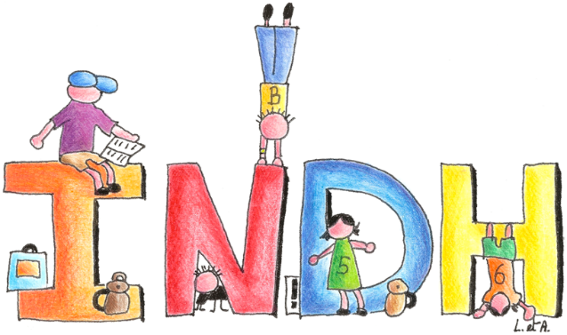
Institut Notre-Dame des Hayeffes
Rue des Hayeffes, 31
1435 Mont-Saint-Guibert
Tél: +32 010/65.53.42
Fax: +32 010/65.06.76
Website: http://www.indh.be
Email: direction8_12@indh.be

Meeting 1:
Team Introductions
Project application overview
Application feedback
Grant funding, payments and implementation
Transnational meetings – documentation and record keeping
Transnational meetings – health / safety, risk assessments, insurance, safeguarding, child protection
Mobility Tool+
Dissemination Task
Reporting and monitoring project
Checklists
Discussion on the following items:
Website / YouTube channel / eTwinning portal / Press Kit / Project Logo / Skype / Translation needs / Meeting dates
AOB
Meeting 2:
Discussion of baseline requirements to measure the success and impact of the project.
Teachers to present views and needs of each county’s curriculum.
Preparation of questions.
Meeting 3:
Presentation of first activity by Belgium (INDH):
Mental Well-being
Many schools already use tools to improve the well-being of children, to teach them to relax, to
express themselves, to concentrate. However, these tools are intended for the class group whereas
the aim of our project is to personalise it for each child so that they find answers independently at
school but also outside of it. Until now, the tools used within the school are offered by the teacher at
times decided by them and without it responding to a specific need of each child. It seems important
to us that every child acquires the habit / reflex action of making the process of using a tool under their own initiative. This will lead to development of interpersonal skills such as psychosocial abilities, social skills, relational skills focused on listening, dialogue, cooperation and appeasement, improving their ability to weave, develop and maintain human relationships. Equipping them from childhood prepares them to become responsible and fulfilling adults.

Meeting 4:

Preparation of materials from meetings 2 and 3 to continue.
Translation teams to create resources for each targeted participant

Meeting 5:

Prepared lessons and materials to be quality controlled.
Feedback to coordinator on meeting successes / improvements.

List of participants:
Name | Role | Country | Email
Barbara Grünstäudl | Teacher | Austria | b.gruenstaeudl@gmx.at
Claudia Schierhuber | Teacher | Austria | claudiaschierhuber@gmail.com
Álvaro Ruiz Gómez | Coordinator | Spain | alvaroruiz@sagradafamiliamanises.org
Joana Ricart Boronat | Teacher | Spain | Joanaricart@sagradafamiliamanises.org
Dolo Folgado Mota | Teacher | Spain | dolofolgado@sagradafamiliamanises.org
Adrian Smith | Coordinator | Wales | adrian.smith@erw.cymru
Michele Commander | Teacher | Wales | commanderm2@hwbcymru.net
Amy Mathias | Assistant | Wales | mathiasa24@hwbcymru.net
Jean-Philippe Remacle | Headteacher | Belgium (NC) | saintjoseph_neufchateau@yahoo.fr
Anne Catherine Mariscal | Coordinator | Belgium (NC) | anne-ca.mariscal@hotmail.com
Olivier Maissin | Advisor | Belgium (NC) | isjomaissin@me.com
Catherine Thomas | Teacher | Belgium (NC) | catherine.thomas@belgacom.net
Wibke Levens | Teacher | Germany | wibke.levens@schuleimerlich.de
Christina von Pabrutzki | Teacher | Germany | christina.von.pabrutzki@schuleimerlich.de
Geoffroy Charlier | Headteacher | Belgium (INDH) | direction8_12@indh.be
Vincent Dupont | Coordinator | Belgium (INDH) | dupont.vincent@mac.com
Dany Kerres | Teacher | Belgium (INDH) | dany.kerres@gmail.com
Boccart Justine | Teacher | Belgium (INDH) | jboccart@gmail.com
Coosemans Karine | Headteacher | Belgium (INDH) | direction2_5_8@indh.be
Debroyer Delphine | Teacher | Belgium (INDH) | delphinedebroeyer@hotmail.com
Dewitte Nancy | Teacher | Belgium (INDH) | nancydewitte2308@gmail.com
Jeandrin Stéphanie | Teacher | Belgium (INDH) | loulout1976@hotmail.com
Marichal Léa | Teacher | Belgium (INDH) | leamarichal@hotmail.com
Paris Marie | Teacher | Belgium (INDH) | marieparis81@gmail.com
Surquin Marie | Teacher | Belgium (INDH) | surquinmarie@gmail.com
Van Oostenryk Fanny | Teacher | Belgium (INDH) | fanny.vanoostenryck@hotmail.com
Wilmotte Frédérique | Teacher | Belgium (INDH) | fredwilmotte@gmail.com
Martin Claire | Teacher | Belgium (INDH) | clarinette.martin@yahoo.fr

